# Resources that support the development of a design solution

## Research tools and techniques

We conduct research to attempt to answer specific questions or try to find solutions for given problems. When researching, we collect information from various sources that we will then treat, analyse and interpret, according to the goals and objectives of our research. To do so, there are certain techniques and tools that we can use, and the data collected can be classified as quantitative or qualitative. For each type of data, different tools and techniques are to be used.



Fig 1. Unsplash (n.d.) Conducting research

### Primary research

Primary research is classified as research we physically conduct ourselves. This is research which we carry out in order to understand more about a particular topic, to answer research questions that cannot be answered by secondary research or to confirm secondary research findings. The data collected here will be unique and only accessible to ourselves until it is shared publicly. Examples of primary research tools and techniques include:

* Visiting showrooms, museums, art galleries, sites, etc.
* Taking down notes, photographs or sketches regarding your observations, or creating videos
* Conducting interviews
* Handing out questionnaires
* Discussing the topic with someone

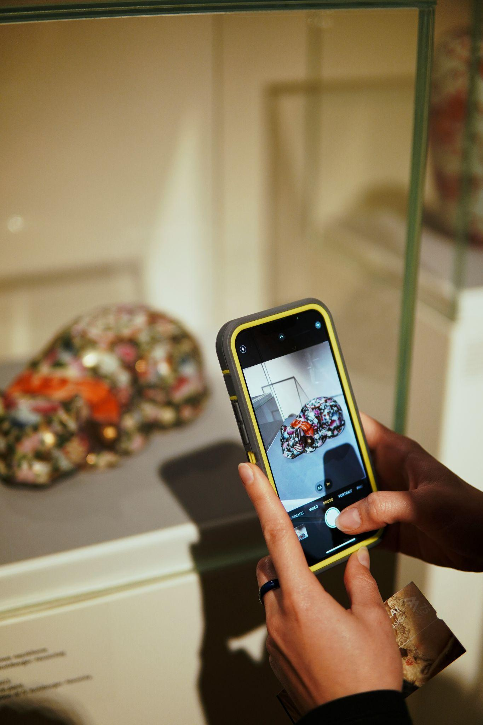

Fig 2. Unsplash (n.d.) Primary research

### Secondary research

Secondary research consists of making use of a variety of existing sources, most of them of easy access, to gather information on a particular topic in order to answer our research questions. In essence, we rely on another person’s content to inform our own understanding of a given subject. Secondary research refers therefore to using information that other people produced and to data that was not directly collected by ourselves (Collins, 2018). Examples of secondary research tools and techniques include:

* Researching on the internet
* Reading articles, blogs, journals, magazines, newspapers, and books
* Accessing information in databases, diaries/memoirs, emails, letters, reports, meeting minutes and interview transcripts
* Watching TV, videos, films, documentaries
* Listening to radio, podcasts and other voice recordings
* Seeing photographs from archives and other images

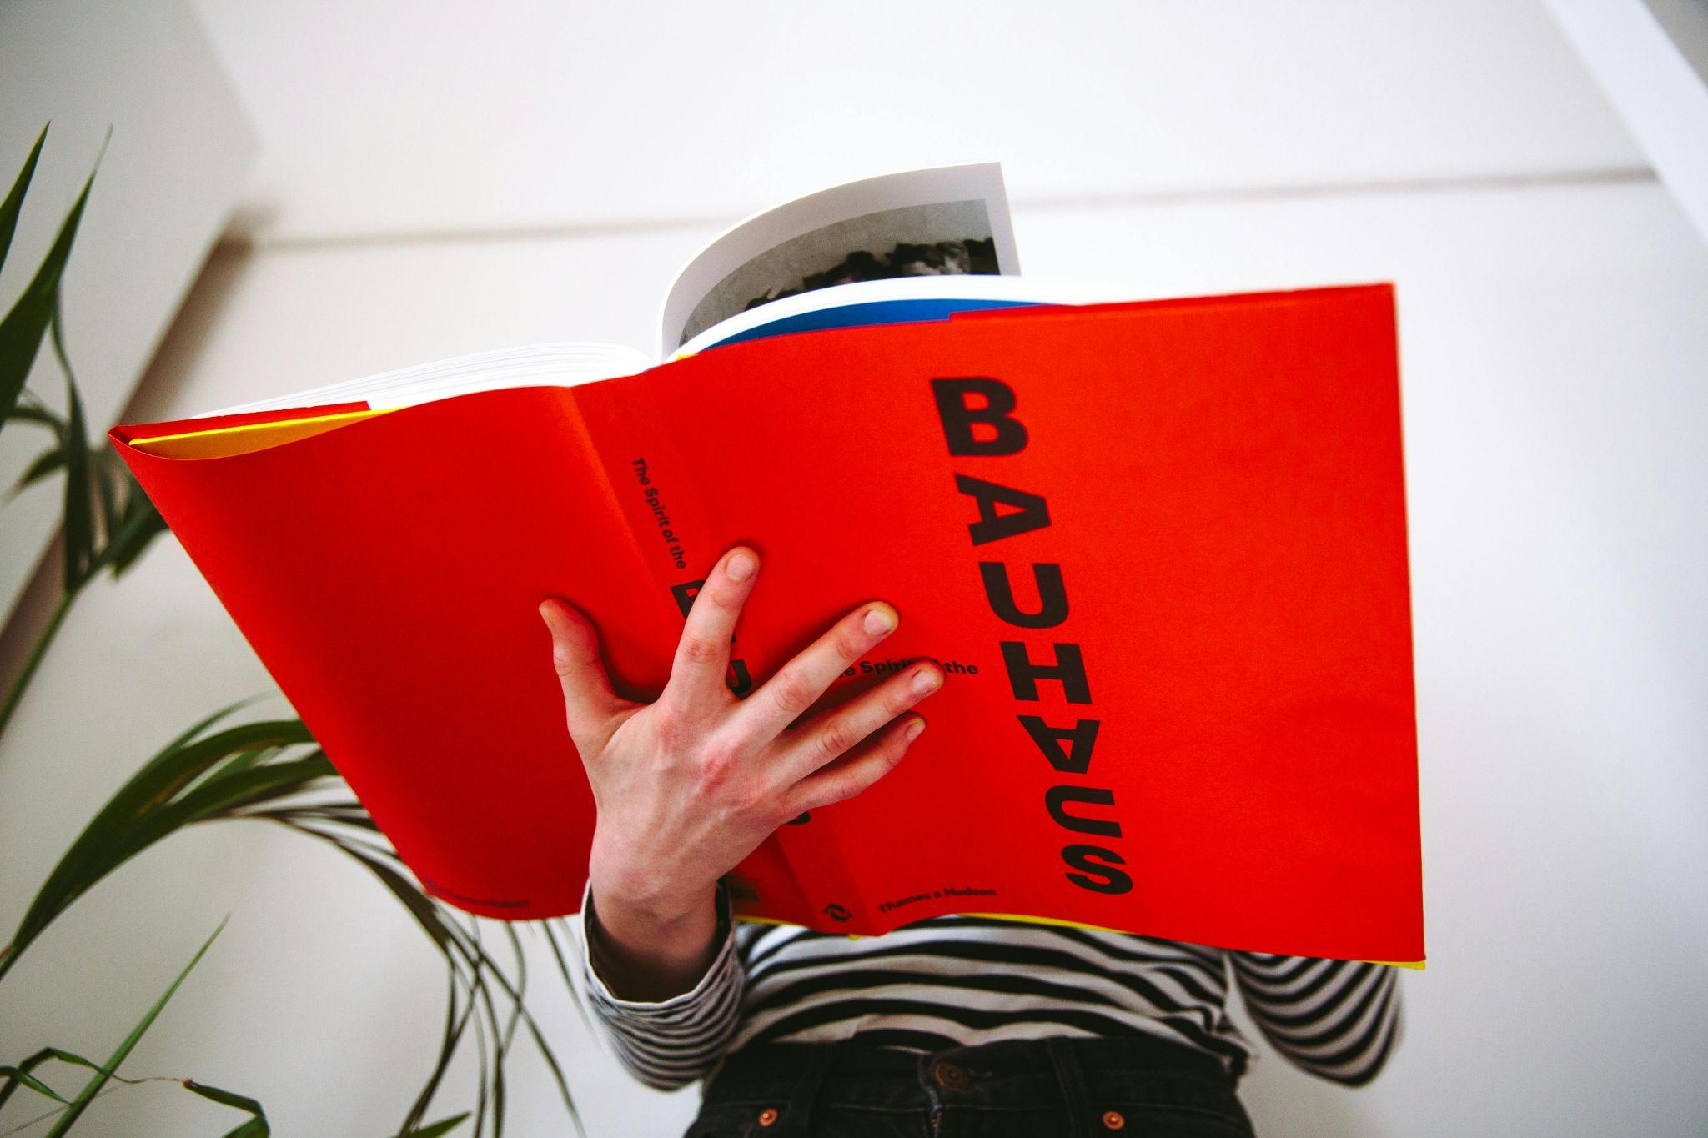

Fig 3. Pexels (n.d.) Secondary research

## Product tools

The job of an interior designer requires certain tools that will help you to excel in the profession. These are tools that will aid you to collect the relevant information you need to develop your concepts and designs, to test and experiment different solutions, and to prepare final design proposals. See below some examples:

* **Measuring tape (standard and laser):** this a basic but essential tool when it comes to conducting site surveys. Traditional measuring tapes are available in a variety of sizes and in addition to these, digital devices will also accurately measure interior spaces.

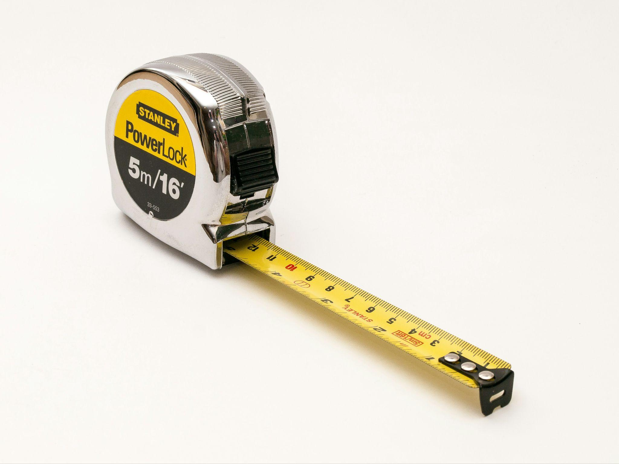

Fig 4. Unsplash (n.d.) Measuring tape

* **Sketchbook:** this is also another essential tool for any designer, working as a visual diary where the designer records any information that is relevant to the development of their work. Sketchbooks are used, for example, to record the information collected in site surveys, but also to explore iterations of visual and textual design ideas through drawings, annotations, collages of images, photos, fabric samples, etc.
* **Photographing device (camera or smartphone):** to ensure that you record all the relevant aspects of a space and that you collect all the necessary information to develop the design proposal, taking photographs is a crucial task and you can do this with the help of a camera or smartphone. The photographing device can also come handy to register any inspirations for your work that you might come across, to register the evolution of works when the design installation begins and finally, to record the final product or how your proposal was delivered to the client in the end.

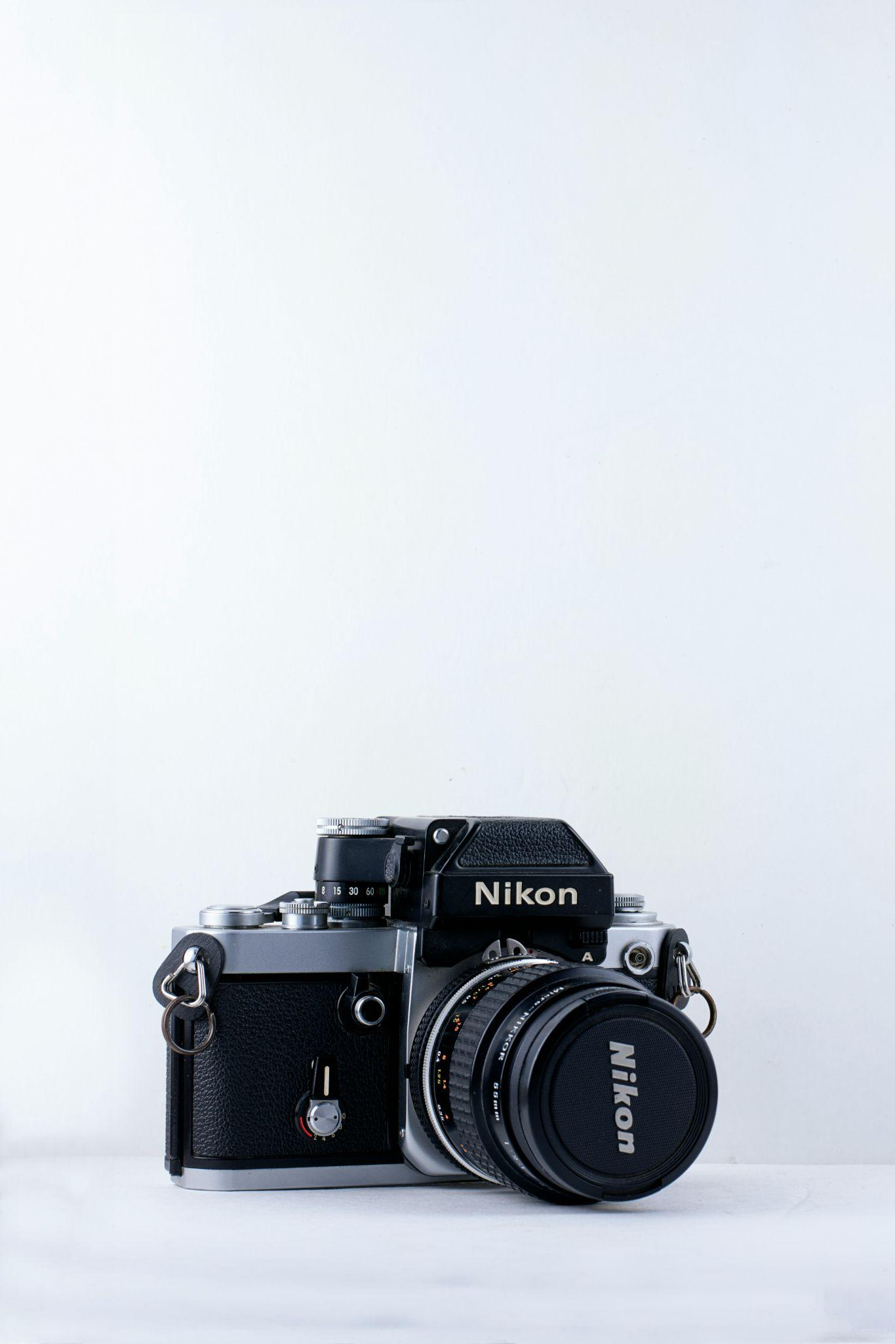

Fig 5. Unsplash (n.d.) Camera

* **Sketching and drawing materials (pencil, pen, ink, coloured pencils, markers, watercolours, pastels, etc.):** these refer to any supplies that you would use to scribble your sketches while you are developing your design ideas and to produce the final technical and polished drawings presenting your proposals.
* **Drawing tools (drawing board, scale ruler, templates, set of squares, compass, protractor, etc.):** all the tools that you would need to produce rigorous and accurate drawings by hand.

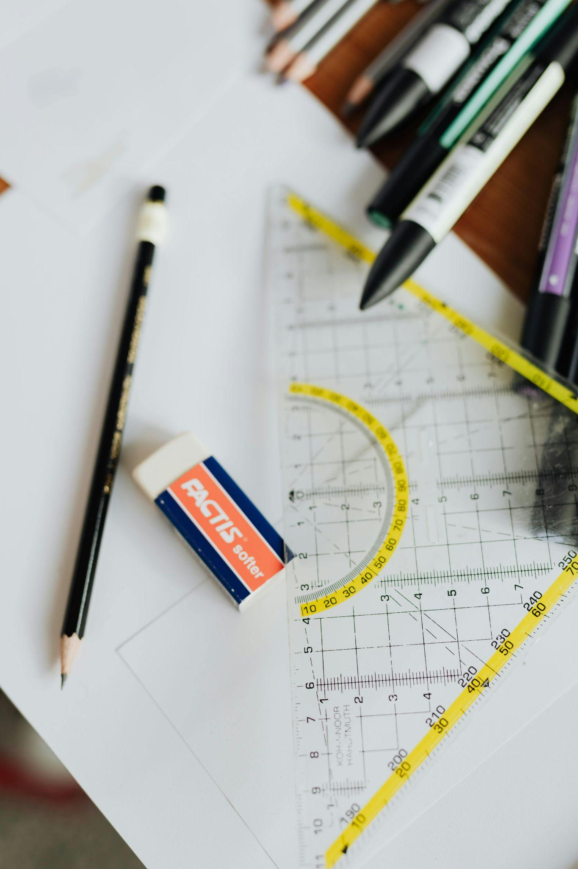

Fig 6. Pexels (n.d.) Drawing tools

* **Computer or laptop:** we live in a digital era and while sketching and drawing by hand is still important as it is a quicker means to put our ideas into the paper, nowadays this is largely complemented by digital drawing as this allows for more accurate and realistic results, and therefore, a computer or laptop is an essential tool for any interior designer.
* **CAD and image editing software:** to produce any digital drawings or imagery, no computer or laptop on its own is enough, we would require specific software for creating 2D or 3D drawings, to render these, or even to create photomontages, collages (for digital sample boards, for example), or any other digital visuals that would aid us to communicate our work.
* **Colour wheel:** working with colour and developing functional colour schemes is a key aspect of the interior design process. A colour wheel will help designers in this process. This is a tool that represents the colour spectrum, helping to explain colour theory and showing the relationship between different colours and different hues.
* **Material samples:** every interior design scheme involves carefully selecting the materials and finishes for the different design elements. Selections or portions of these materials and finishes are used to understand how the whole would look like and how everything would work out together in terms of colours, textures, patterns, etc., therefore, an interior designer should source samples or swatches directly from the manufacturer in order to build a library of samples that they can refer back to whenever they are developing a new project (this would include samples of flooring, tiles, wallpaper, fabrics for upholstering or window treatments, wooden finishes for custom made pieces, paint swatches, among others) (Coates et al., 2009). It’s also important to keep updated in regards to the latest industry trends, so this library of samples should be constantly updated.

### Communication tools

Any interior designer will have to master the art of communicating, not only with their clients but also with tradespeople, suppliers, manufacturers, etc. The designer has the duty of clearly communicating their ideas and proposals, this is what will allow them to effectively sell their projects and to ensure that everything is supplied and built according to what they have planned.

* **Visuals:** this refers to any sketches, drawings (floor plans, elevations, sections, perspectives, etc.) collages or any other imagery that the designer creates to communicate their concepts, the development of their work and their final proposals. You can present these elements individually or assemble them in a board, as explained below.

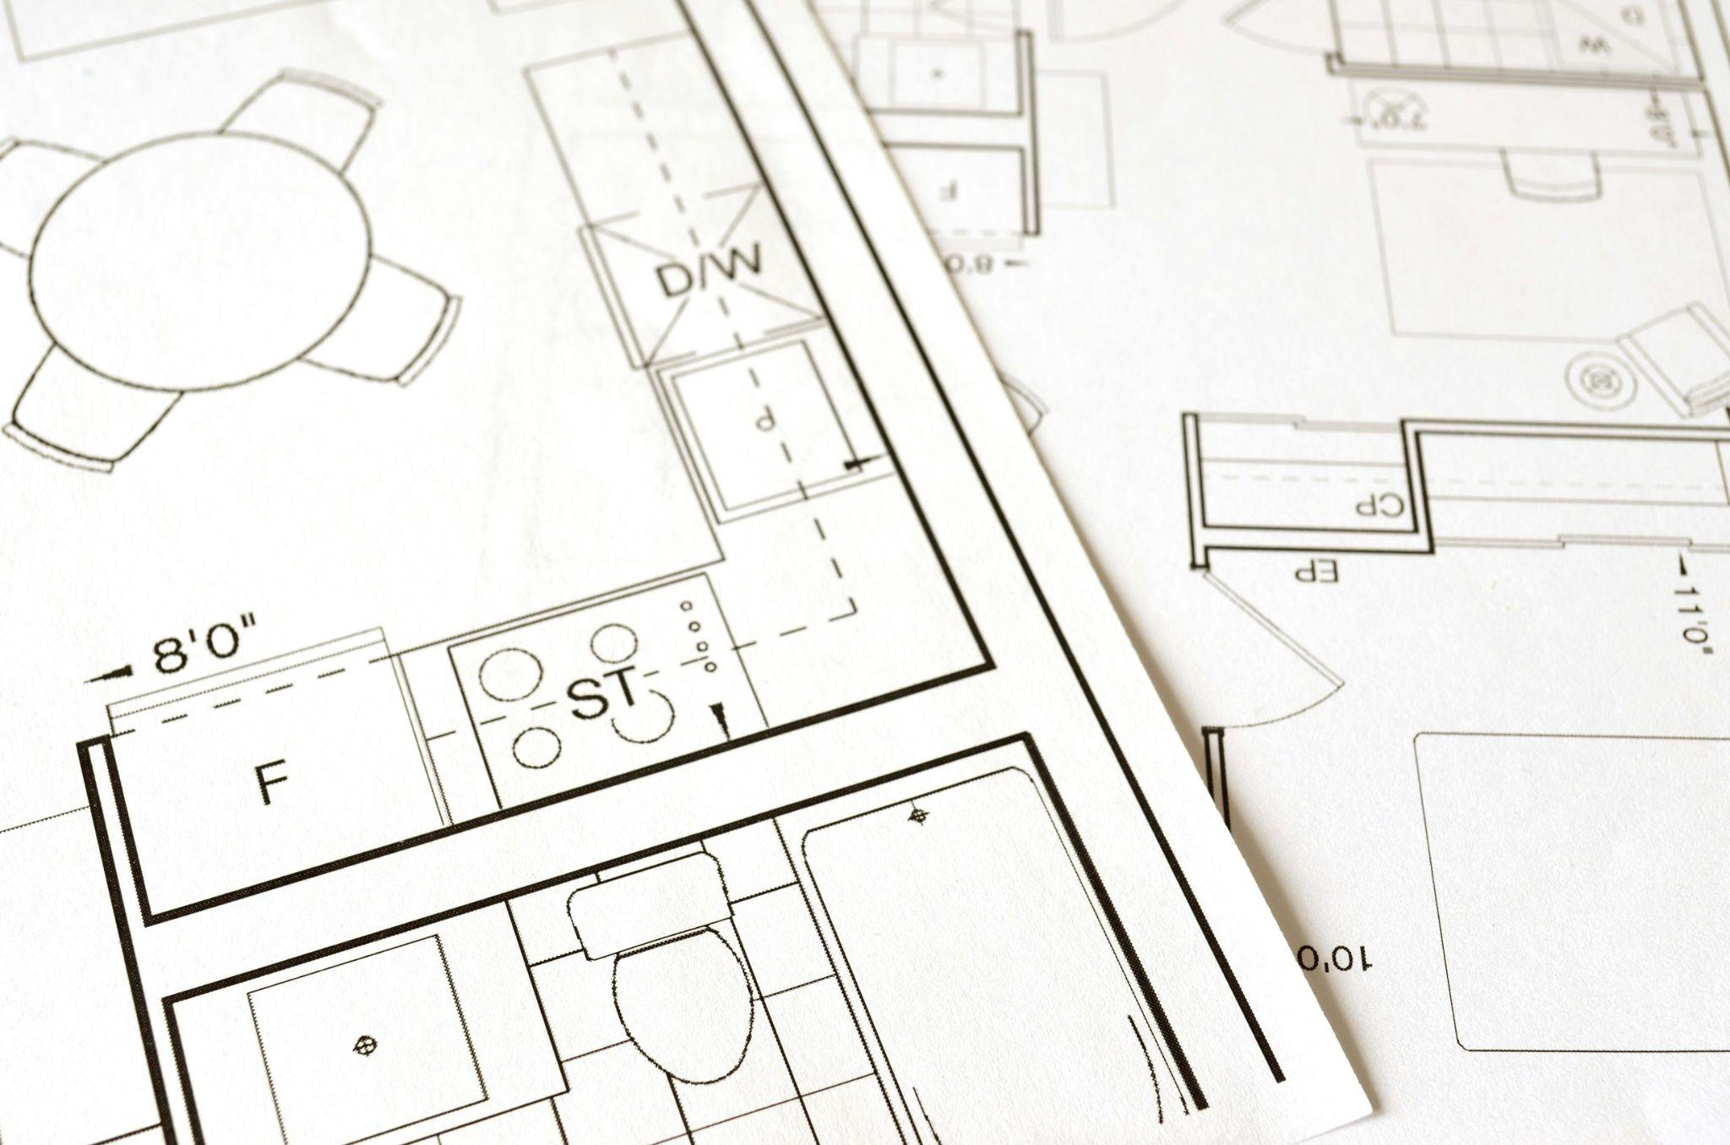

Fig 7. Pexels (n.d.) Floor plans

* **Presentation boards:** these boards are used to communicate inspirations, ideas, concepts and final proposals to a defined audience, telling the story of the design in a clear and concise manner. Presentation boards can be composed of drawings, images, samples and texts, according to their type, and can be either physical or digital. Types of presentation boards include:
  + **Mood boards:** produced at an early stage of the design development, these create the mood and set the tone for the project work that follows through the arrangement of visual materials that show the designer’s attitude and inspiration.
  + **Concept boards:** a concept board can often replace a mood board but it can also be a more visually oriented piece used to introduce a specific theme or a topic within a project.
  + **Colour boards:** these are used to communicate a colour direction or the colour scheme selected for the project. Although the desired colour palette can also be communicated through a mood board or a concept board, having a dedicated colour board with different visual elements such as paint swatches, fabrics, textures, etc. would be a nice addition to any project (Hopkins, 2018).
  + **Development boards:** the designer can use a board to communicate the development process of the project. These boards portray key development moments of translating an idea into a specific design and can include a variety of sketches, drawings, images, photographs and can even include material samples, anything that makes sense to tell the story behind the design.
  + **Sample boards:** any project will imply the selection of specific materials, finishes, furnishings, furniture, fixtures and equipment. Sample boards are produced after the design is fully developed and are used to communicate the final proposals for each one of these elements through an intentional arrangement of material samples and/or images. Sample boards should be labelled in a way that they can be read in conjunction with the technical documentation of the project, giving important guidance to both clients and tradespeople as to how the project should look like in reality.
  + **Design boards:** these are produced to communicate the finished product and will therefore include relevant technical drawings, rendered visuals, texts, anything that helps to show how the project will look like after implementation. These boards are the final visual narrative of the project.
* **Presentation software and multimedia presentations:** throughout the development of any project there are several moments where the designer meets with the client, either to communicate how the design is coming together or to present final proposals. Digital technologies are important tools for the designers to produce presentations for these moments that are professional, clear, informative and visually appealing. In a world where the online and remote are becoming the order, multimedia presentations (combining text, visuals, video and sound) are interesting because they allow the designer to create presentations that can be viewed without the designer being present. Software and applications that would be used to create these presentations include, among others, PowerPoint, Keynote, Impress, Prezi, etc.
* **Email:** In this digital era, any interior designer should have a professional email address used to communicate with clients, suppliers, manufacturers, tradespeople, etc. This is often the main route of communication that designers use to make checkpoints with their clients throughout the development process of the design or to send the client and other people involved in the project important information about it (sketches, drawings, images, technical specifications, etc.).
* **Cloud-based computing:** cloud-based software can also be used for communication between any intervenients in a project, allowing people to share documentation and to work collaboratively, as this type of software allows for an easy allocation of tasks. The designer will often prepare the documentation and upload it here and everyone involved would get access to it. Any alterations to the project’s drawings, specifications, etc. would be quickly communicated, monitored and accessible to all parties.
* **Messaging apps/smartphone:** For a quick checkpoint with the client or with any members of the team involved in the development and implementation of the project, messaging apps/smartphones can also be used. Messaging apps such as WhatsApp are more instant than using the email and will allow the designer to quickly share images and files between the intervenients, which is particularly useful when there are urgent matters to be dealt with.
* **Video conferencing suite:** The ‘face to face’ nowadays does not necessarily mean that people will have to be in the same room. Applications such as Skype, Zoom, Microsoft Teams, among others, allow the designer to communicate and meet with the client or with any other people involved in the project, presenting work and sharing with them all the details about the design. This is a flexible means of communication, as anyone with an internet connection would be able to access these platforms and meet from anywhere.